

Installation manual

Product Information

Passenger side brake serial number: ___________________________________________________

SCM serial number: ____________________________________________________________

Installer: _____________________________________________________________________
____________________________________________________________________________
____________________________________________________________________________

Date Installed: _________________________


Technical & customer support:
1 888 370 5050
Info@tarsussystems.com

(i) Introduction
This manual outline installation and maintenance of the Tarsus passenger side brake and accelerator system. The Tarsus passenger side brake is a universal product designed to be mounted to the passenger side accelerator floor or firewall of a vehicle. It actuates the brake on the driver side using a cable and pully system.
Caution: Before installation read fully and understand steps required for installation, we recommend this product is installed by a professional mechanic. Installer assumes all liability if installed incorrectly.
(ii) Tools required
The following is a tool list for install and adjustment of the Tarsus passenger-side brake and accelerator system. This does not include a tool list for the removal and install of OEM vehicle components.
Combination Wrenches 3/4”, 5/8”, 9/16”, 1/2”, 7/16”
3/8” ratchet drive + extension
1/4” ratchet drive + extension
Socket 1/2”, 9/16”, 7/16”, 3/8”,
Allen key 1/8”, 5/32”, 3/16”, 1/4”
Drill (right angle pneumatic drill suggested)
Drill bit 21/64th
Impact Drive (suggested)
Hack saw
16mm hole saw
Digital Volt Ohm Multimeter (DVOM)
#2 Phillips screwdriver

(iii) Assembly Drawing
For component brake down please see Appendix. (item 3 is optional)
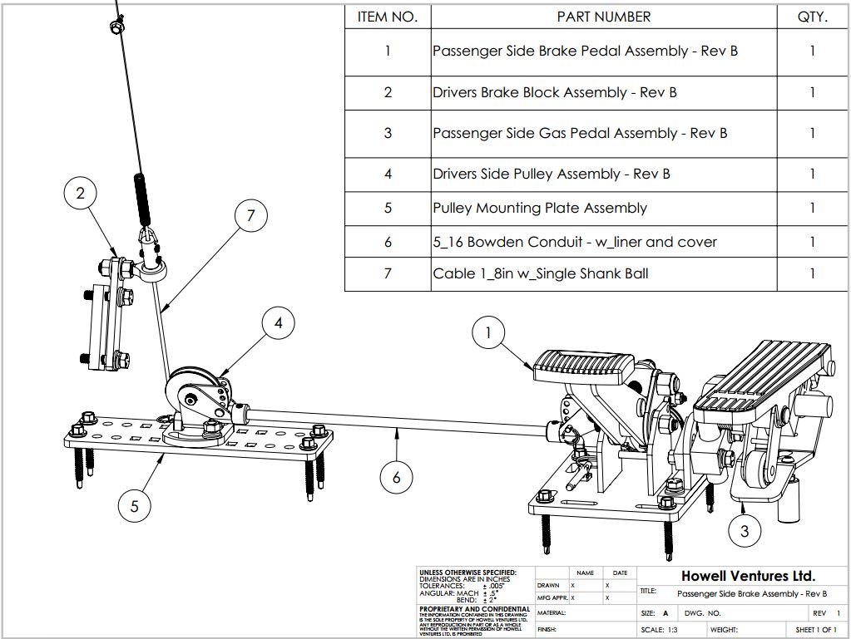

- Safety Precautions

Observe All safety precautions. Failure to do so could result in damage to the vehicle, property and/or personal injury, or death.
- Observe all safety precautions when using all tools
- Correct PPE for automotive work must be worn throughout the install.
- Installation should only be performed by a certified technician.
- Final fittings and adjustments must be performed before allowing the user to operate the passenger-side brake.

2.0 Pre-installation Check

Check vehicle OEM braking system.
Take the vehicle on a test drive to ensure that brakes are operating correctly, and other vehicle modifications do not interfere with normal brake operation. Visually check all braking components for wear. If any issues are found, they need to be addressed before installing Tarsus passenger side brake and accelerator.
Installation instructions have been read completely, if there are any questions about the content please contact us at 1 888 370 5050


3.0 Installation Overview
Overview of Installation steps is as follows:
- Mounting for pedal assembly
- Run cable from passenger side accelerator to driver-side
- Mount driver-side pully
- Driver-side cable attachment
- Auxiliary accelerator mounting
- Electronic component installation

4.0 Pedal base prep

Slide cable through captive bolt.
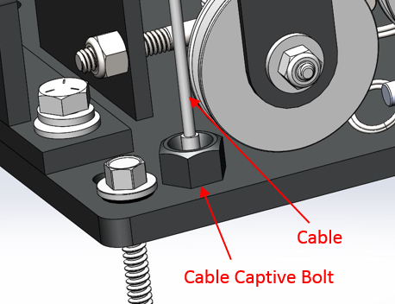
Figure 1: captive bolt.
The captive bolt allows you to remove the cable from the pedal assembly without unbolting the pedal. When shipped It is already attached to the pedal base. Simply unbolt the captive bolt if cable replacement is required.

4.1 Passenger-side Accelerator Attachment
This section is only applicable if the passenger side accelerator is required, move to sec. 5.0 If no accelerator is being installed.
Bolt swivel bracket to the base using 5/16 hex bolts, lock washers and flat washers. Final torque 17 ft/lb.
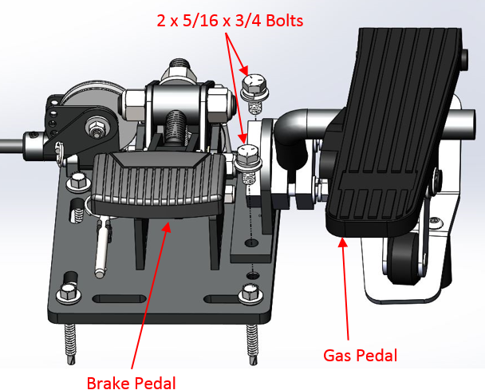
Figure 2: accelerator attachment.
Attach clamping block to swivel bracket assembly using thread block and hardware supplied with clamping block kit. Leave loose until final fitment. Final torque to 17 ft/lb. Reference Fig. 2 for placement.
The other clamping block kit is attached to the inside of the passenger side accelerator pedal base plate, using holes in Fig. 3. Cycle pedal to make sure there is no interference with the clamping block throughout its travel.

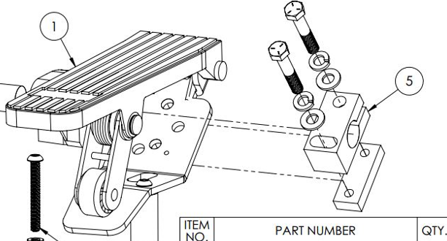
Clamping block
Figure 3: accelerator pedal clamping block.

The harness clamps on the pedal and the base must be removed using #2 Phillips. Figure 4

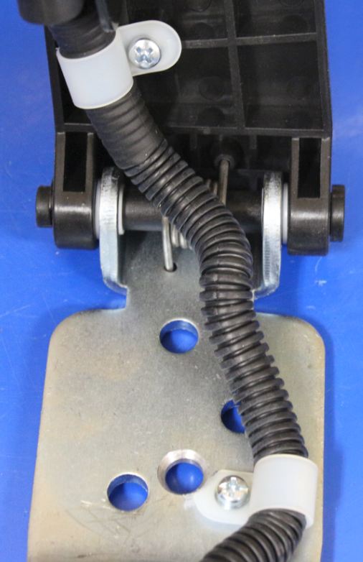
Figure 4: accelerator base “P” clamps.

Use zip ties to secure to support rod as shown in Figure 5

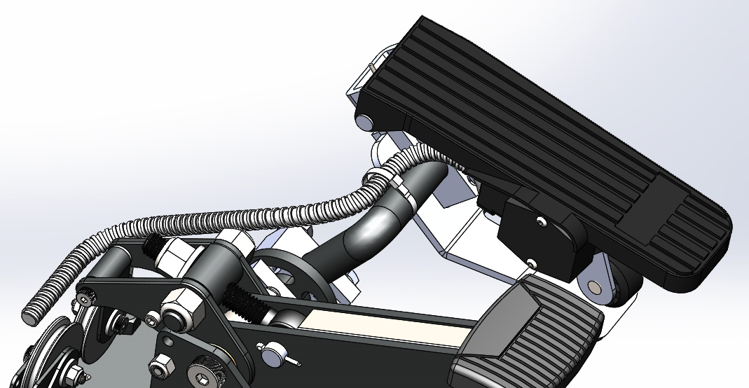
Figure 5: Harness routing.

Once both clamping blocks are mounted attach the passenger side accelerator to the swivel bracket using the supplied support rod. Tighten enough to hold assemblies in place but allow for movement when test fitting into the vehicle.

5.0 Choosing Suitable Mounting Location

Tarsus brake is to be mounted to the floor or firewall. Ensure to use 4 mounting points on the pedal base. You will have to inspect from under the vehicle and from the top side under the carpet. Check for obstructions such as:
- Wiring harnesses
- Fuel lines
- Break lines
- Foam/ composite floors
Caution: failure to check for obstructions can lead to malfunction of OEM components or failure of the Passenger side brake to operate correctly.
The pedal must be mounted to solid floor or firewall, it is preferable to use through bolts. In cases where there is no access to the bottom side due to subframe or converging body panels, self-taping screws can be used.
If there is a foam spacer or composite floor a custom plate will have to be fabricated or alternate mount location. Please call Sure Grip tech support at 1 888 370 5050
It is important to place the pedal in an area that does not intrude on the occupant's leg space when not in use and is easy for the passenger to operate.
Pedal location will vary when paired with the passenger side accelerator, place assembly as far to the right as possible.
Cable routing must be considered when choosing location, the straighter the cable easier the pedal is to operate. Plan where the cable will be fed behind the dash.

6.0 Pedal Height Adjustment
Once a suitable location is found it is important to adjust the pedal height for comfortable and safe operation. The quickest way to ensure this is to copy the spacing of the OEM brake and gas on the driver’s side of the vehicle.
- The brake pedal pad must be on a higher plane than the gas pedal
- The brake pedal and gas pedal must be separated a minimum of 2.5”
Further the distance between the two pedals will decrease the chance of using the gas and brake at the same time. The same goes for the height of the pedal, the higher the brake pedal is compared to the accelerator it lessens the chance of unintentional throttle. However, must make sure separation is not so great as to make use of the pedal uncomfortable.
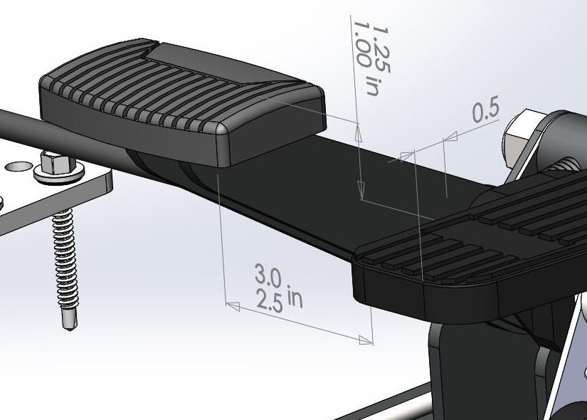
Figure 6: pedal height.

6.1 Brake Pedal Adjustment
Loosen nylock nuts on the sides of the pedal arm using a 3/4 wrench or socket (1). Using a deep socket or wrench adjust the height by loosening or tightening the adjustment nut (2). Tighten the nylock nuts on the side of the pedal arm once the desired height is achieved. See Figure 7
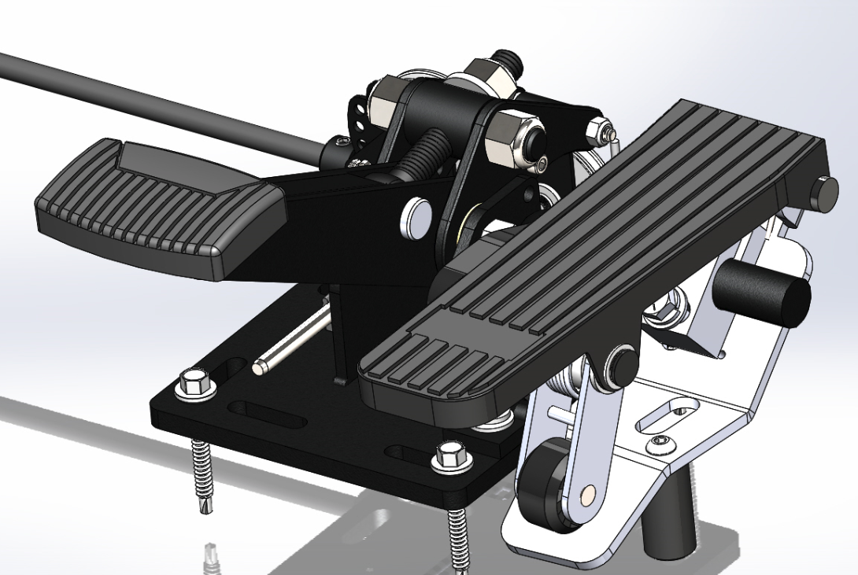
2
1
Figure 7: Brake pedal adjustment

6.2 Gas Pedal Adjustment
The gas pedal location is largely determined by the support rod. The location of the accelerator can be adjusted by:
- Rotation of clamping block in the swivel bracket
- Sliding support rod in and out of clamping block
- Rotating the pedal on the support rod
- Sliding pedal on the support rod
The support rod can be cut or bent to fit any floor shape or space constraint. Clamping blocks only need 3/4” of a rod inserted for securement (flush with the end of the clamping clock).
The gas pedal base must be in contact with the floor of the vehicle. This can be adjusted depending on the height or angle that is desired.
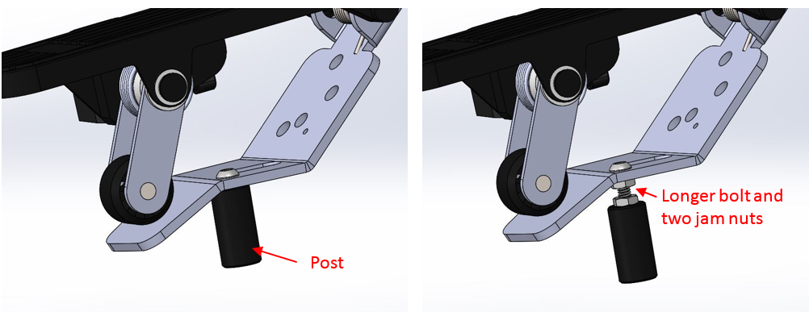
Figure 8: Post adjustment.

The post attached to the bottom of the pedal base can be removed completely if the edge of the pedal base can touch the floor or if a lower height is required. If the pedal height requires the pedal to be raised add the longer bolt and jam nuts that are included in the swivel bracket package.
7.0 Pedal Mounting
Once a suitable location has been chosen that allows for the following:
- Solid mounting
- No obstructions
- Comfortable use
- Safe use
The pedal is attached using any of the 4 slots in the brake pedal base plate. The most desirable 4 mounting points are as close to the corners of the base plate as possible.
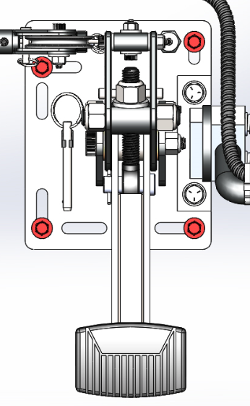
Figure 9: Pedal mounting points

Use the supplied self-taping screws to attach to the vehicle. Attach using a 3/8 socket and a drill, a right-angle drill may make the operation easier for upper mounting locations. Through bolts are preferred mounting hardware but 4 self-tapping screws are acceptable for installs that it is not possible to use through bolts.
Ensure the mount is solid.

8.0 Cable
Run the cable through pully on pedal arm and then through base plate pully assembly. See figure 9
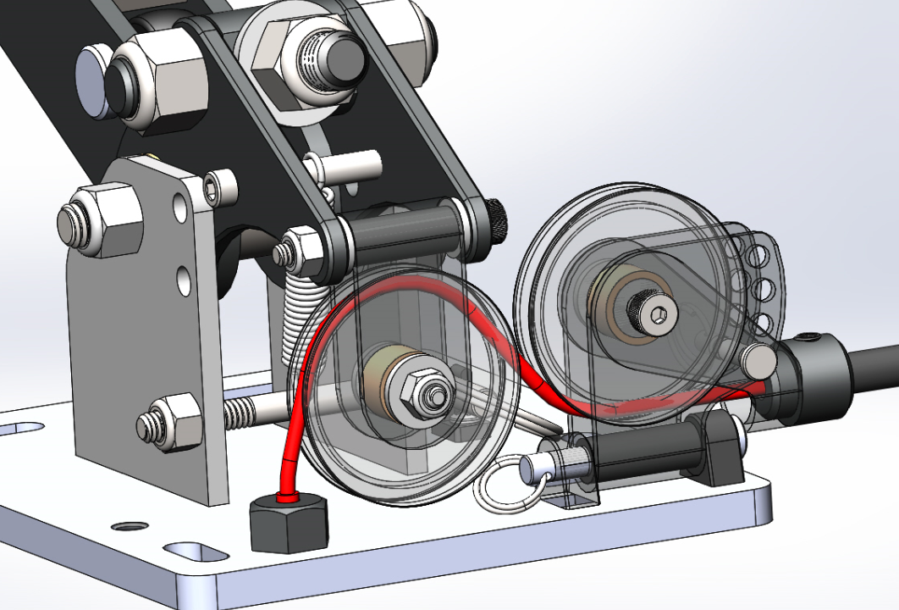
Figure 10: Cable routing.

Slide cable through cable sheath and temporally run over to the other side of the vehicle. Most commonly there is a gap behind the dash where the center console is met. There may be a possibility that the cable has to be run higher in the dash assembly. See figure 10
When routing through the dash make sure there are no sharp bends.
Loosen set screw in cable guide using 1/8 Allen and seat sheath in completely in the guide. The guide allows for the sheath to be inserted 1/2”
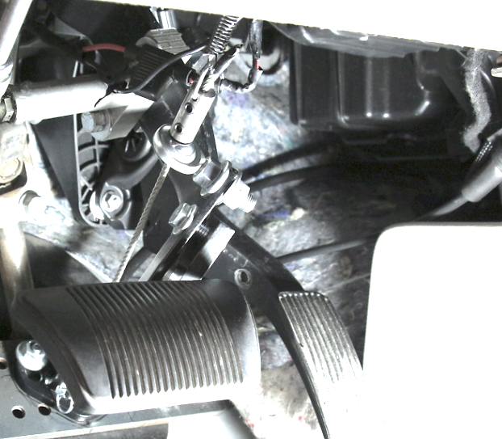
Figure 13: most common cable routing through the dash.

8.1 Pully Guide Adjustment
The base plate pully angle guide can be adjusted to give a better trajectory over the transmission tunnel or if the cable has to be routed higher in dash assembly.
First, loosen the pulley bolt using 1/8 Allen and 3/8 socket, only loosen enough to allow the guide to slide freely. Then remove the pin and slide the guide to the desired position, each hole offers 15 degrees of adjustment.
Replace pin and cotter ring when adjustment is complete. Guide is shipped in the second lowest hole.

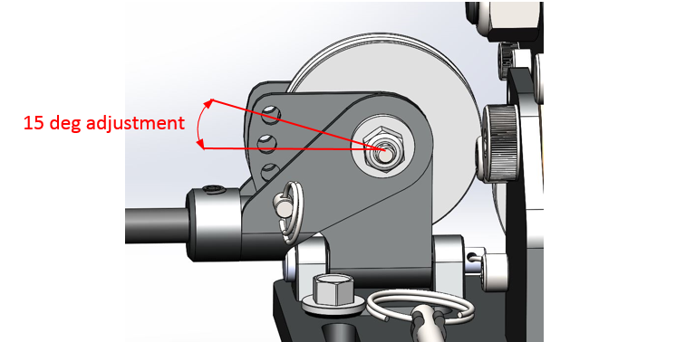
Figure 12: Pully angle adjustment
Once the final trajectory is determined. Tighten the pulley bolt to 20in/lb. (hand tight) Using 1/8” Allen and 3/8 socket.

9.0 Brake Pedal Block Attachment
Attach the brake block assembly to the driver’s side pedal arm, leave your hand tight at this time so you can slide on the OEM brake arm for adjustment. We do not want the driver’s feet to come in contact with any component of the brake block. Final torque 17 ft/lb.
To help with cable alignment the ball joint attached to the pedal block can be adjusted by threading the attached bolts. Ensure bolts are tight once the final location is determined.
Note: the lower the brake block is mounted on the pedal arm the easier it is to apply the brakes, but this increases the travel. The higher the brake block is mounted on the pedal arm the more difficult it is to apply the brake, but this decreases the pedal travel.
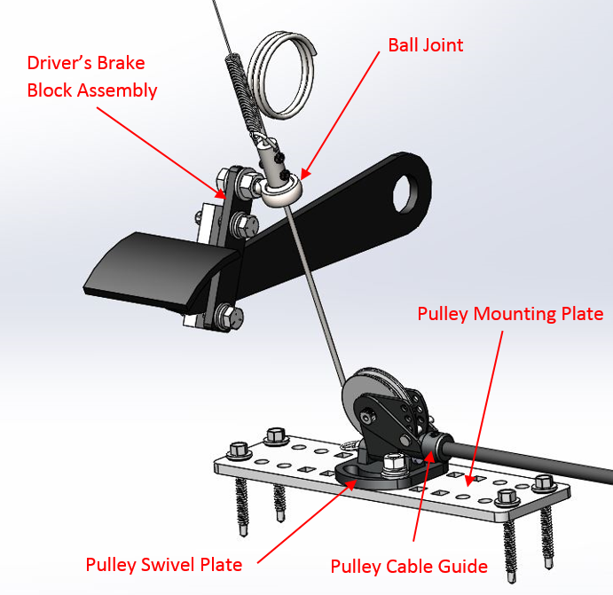
Figure 13: Driver-side assembly

9.1 Driver-side Pulley Mounting
The driver-side pully must be mounted directly in line with the ball joint on the pedal block assembly. As straight as possible pull throughout the pedal travel is imperative to longevity and smooth operation.
Note: using the cable to line up the pully can make for easy visualization of where the pulley needs to be mounted
If the firewall is suitable for mounting the pully using through bolts the two supplied 5/16” x 2” Grade 5 bolts can be used. Hold the swivel bracket in place and mark for holes to be drilled, using a 21/64” drill bit. Self-taping screws alone cannot be used in a pulley swivel plate and require a pulley mounting plate.
There must be one bolt in each slot on the swivel pully bracket, use washers on both sides and final and torque 17 ft/lb.
Caution: Check for obstructions. See sec 5.0
When the firewall is not suitable for mounting swivel block directly because of gaps (e.g. steering shaft boots) or if it is not possible to access the back side of the subframe or converging panels. Use the pulley mounting plate. See Fig.14.
The pully swivel plate is mounted using two plow bolts in the square holes in the mounting plate, this allows for tightening from one side after the plate has been mounted. See Fig 13
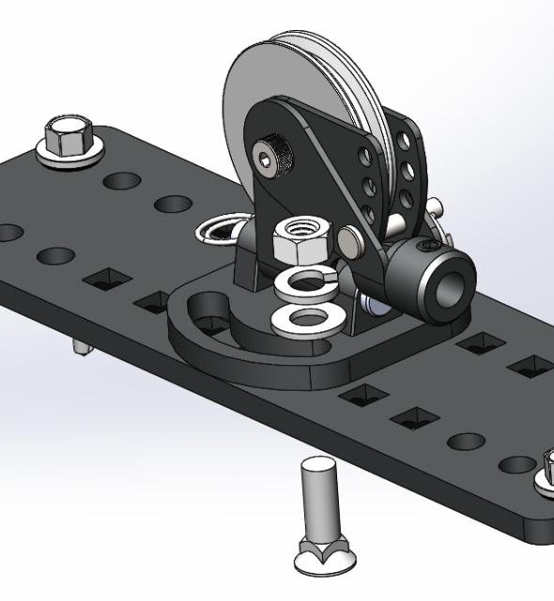
Figure 14: Pully mounting plate assembly

To mount the plate to the vehicle using any hole is suitable for the self-tappers. A minimum of 4 self-tappers are required. The plate may also require trimming to fit in some areas.
If possible, mount the pate under the carpet and cut the section for the pulley to protrude. This is just for aesthetics and if it is not possible the plate can be mounted on top of the carpet.
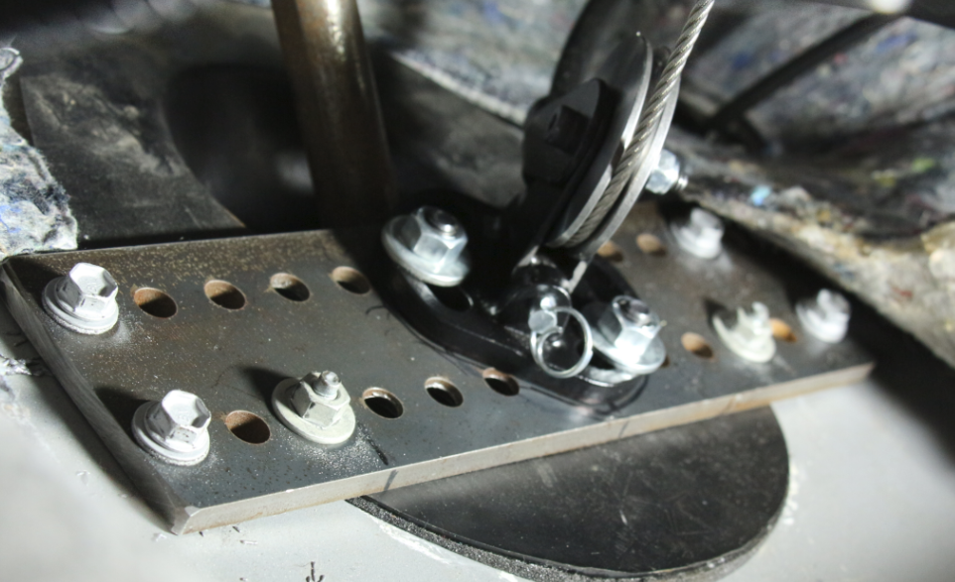
OEM bolts
Figure 15: Pully mounting pate.
Caution: Check OEM pedal travel with the vehicle started and cycle fully. The brake cannot come in contact with the driver-side pulley.
Caution: If spanning the steering shaft boot, test Clarence by completing full left and right rotations of the steering wheel (lock to lock). The shaft must not come in contact with the plate.
Note: The OEM bolts were only used because they were conveniently placed. They are not required for pully mount.

9.2 Drivers-side Pulley Guide Adjustment
As with the passenger side accelerator pulley, you can change the trajectory using the pin in the pully, follow the steps in sec 8.1.
Along with the pulley guide the slots in the base allow the pulley to be positioned in a fashion that does not put too sharp of a bend in the cable sheath.

10.0 Cable Sheath
With driver-side pully assembly and instructor pedal mounted, make sure the cable sheath is seated in the cable guide.
Routed to driver side pully with no kinks and does not contact moving components
Hold the cable sheath up to the driver-side cable guide and mark where to cut. The sheath sits 1/2” in the cable guide.
Remove the sheath from the vehicle. Cut with a hack saw and remove all burs from the inner edge. Make sure the heat from deburring does not damage the inner plastic liner. If a deburring tool is used it must spin in the counterclockwise direction to avoid opening the metal spiral layer of conduit.
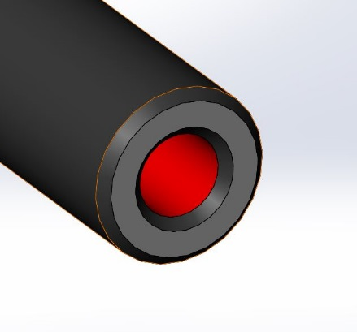
Remove burrs
Figure 16: Cable Sheath

Refit cable conduit into the vehicle, first in the cable guide on the passenger side accelerator and tighten the set screw using 1/8 Allen key.
Route cable through to the driver's side of the vehicle.
Pass the cable through the drive side pully and insert the cable sheath into the cable guide and tighten the set screw using the 1/8 Allen key.

11.0 Cable Termination Lug
Route cable through the center of the ball joint.
Slide cable termination lug with “D” ring facing away from ball joint onto to cable.
Pull all slack from the assembly’s place cable termination lug against the ball joint and tighten set screws. The final torque spec for set screws is 20 in/lb (hand tight)
Affixed the return spring to the “D” ring on top of the cable termination lug by spreading the halves eyelet and rotating the spring on.
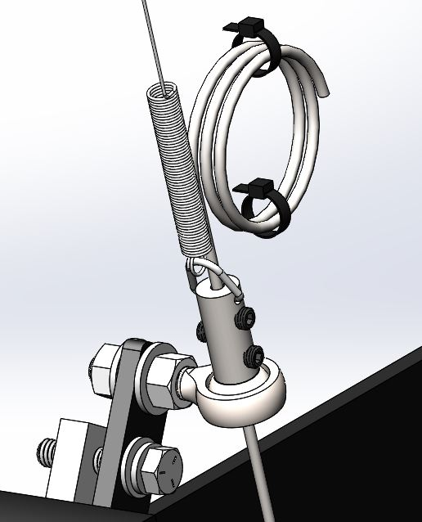
Figure 17: Cable termination lug

The purpose of the spring is to hold the cable taught while the OEM brake pedal is depressed, and the passenger side brake is not. This is so cable damage does not occur or interfere with OEM brake operation. The spring also acts as a secondary return spring for the OEM pedal, helping it return to the neutral position.
The other end of the spring is attached to the vehicle's dash structure using the supplied self-tapping screw (5/16 socket) and wrapping the spring around it. OEM bolt or stud can be used if there is a suitable location
Note: The lower dash panel may require removal for easy access to the dash structure.
Coil up excess cable and attach to self, using supplied zip tires. See example fig.16, it is not recommended to cut the cable. Excess cable cannot be attached to other components as it must move freely with the cable termination lug.
If the installer chooses to cut the cable it should be cut a minimum of 1” above the cable termination lug and a suitable method must be used to prevent the cable from fraying
Caution: Cable termination lug, spring or excess cable must not come in contact with other components or vehicle occupants.

13.0 Passenger-side Brake Final Checks
- Cycle passenger side brake multiple times with vehicle started while in park to test operation. Ensure there is no contact with OEM components throughout travel.
- With the vehicle started and OEM brake must return to neutral position. Make sure the brake lights turn off.
- Test the vehicle with a partner in the parking lot to make sure the vehicle can be brought to a full stop.
- Test drive the vehicle for 10 minutes to ensure OEM braking function is not affected.
- Quick-release lock-out pin placed in a holder on the base.

14.0 Maintenance
The system should be checked annually, all components should be inspected for wear and replaced as required. If the passenger side brake is used as a primary driving brake, an inspection is required every 6 months.
Inspect cable for Fraying. If any fraying is detected cable must be replaced.
It is normal for cable to stretch up to 1/4” from the initial install, which will require slack to be removed at the cable termination lug. Once slack is removed make sure set screws are tightened and thread locking compound is applied See section 11.
Inspect pulleys for wear in cable grooves and bushings. Assemblies must operate smoothly.
Removable pins on pulleys should be lubricated using a small amount of white lithium grease.
Cycle brake with the vehicle running to check use.
Users should check the brake daily for before use, to ensure all components are operating correctly.

For warranty information please visit a website.
https://www.tarsussystem.com/warranty

15.0 Tarsus Electrical Installation Overview
Figure 18 depicts the Tarsus connector layout for the electrical system
Note: When Installing any of the electrical components, ensure the vehicle is not powered.
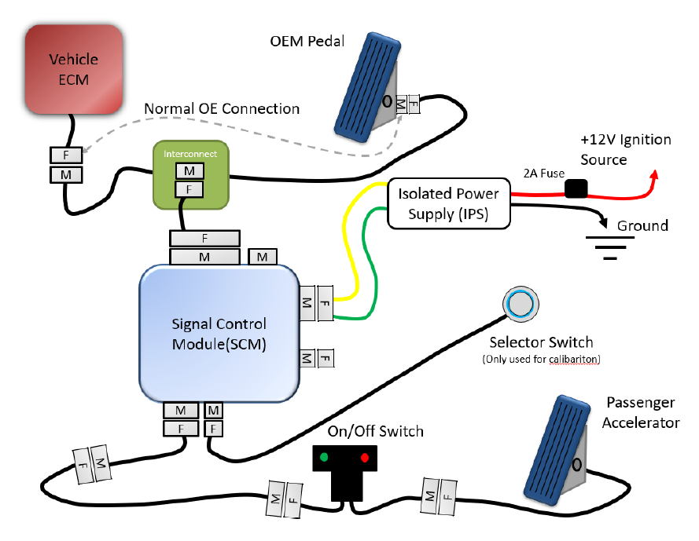
For Install ONLY
Figure 18: Electrical Overview

16.0 Isolated Power Supply (IPS)
Solder the red wire from IPS to the 12V ignition source. The recommended source will be given on the Interconnect module configuration sheet, provided with your Interconnect Module.
always test the power source using a digital voltmeter to ensure it is 12V with the ignition on and 0V with the ignition turned off.
Install the Black wire to the chassis ground. If possible, use a pre-existing OEM ground location.
Warning: The brown wire is not used during a Tarsus installation. Secure and tie off the cable. (See section 24.0)

Caution: Do not use Scotch locks or any style of wiretaps, system requires a good connection.
Note: Power take-off fuse(add-a-Fuse) holders can be used if the fuse block is easily accessible. A fuse with the correct amperage rating for a tapped circuit must be used.
Note: Crimped connectors can be used if proper Crimping pliers are used. Soldered connections are preferred.

17.0 Interconnect Module (ICM)
The Interconnect module is installed between the accelerator pedal and the accelerator pedal harness (between the engine control module).
The ICM is shipped with accelerator pedal connectors plugged into each other. Use this to learn how the locks on the APC work before you try to unplug the ones in the vehicle.
Locate the OEM accelerator pedal connector and disconnect it.
CAUTION: If vehicle power is not turned off this will code the vehicle.
Connect ICM in line with the accelerator pedal. Ensure the ECM side of the ICM is plugged into the harness going to the vehicle. Ensure the Pedal side of the ICM is going to the accelerator pedal. See Figure 19
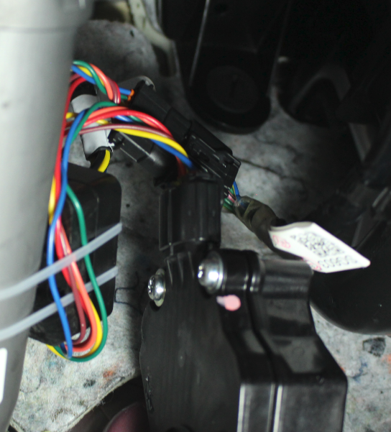
Pedal Connector
ECM Connector
ICM
Figure 19: ICM mounting
Connect the ICM harness (Figure 20) and secure the ICM out of the way using cable tires. Ensure ICM will not interfere with OEM components or is close to heat sources such as heater vents. Please read section 24.0 before mounting the ICM module.

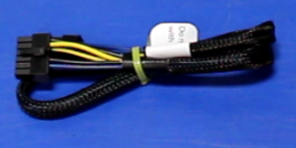
Figure 20: ICM harness

18.0 On/Off switch
Plug the on/off switch into the passenger accelerator.
Peel the backing off the adhesive and mount it in a location that is easy to access for the user. Ensure the mounting location is free of dirt and oils. Screws can also be used to mount the switch (not included).

19.0 Extension Harness (SCM.EXT)
The extension harness is packaged with the on/off switch
Plug SCM.EXT into the on/off switch.
Run SCM.EXT through the dash to the mounting location for SCM.

20.0 Signal control module (SCM)
See Figures 18 and 21 for reference
SCM can be mounted high up in the vehicle dash to avoid moisture damage. The best-suited location will depend on where power is being tapped.
Plug IPS 8 Pin connector into SCM plug (#1)
Connect ICM harness 12-pin connector into SCM plug (#2)
Insert SCM.EXT 6 pin connectors into SCM plug (#3)
Plug 4 pin selector switch into SCM plug (#4)
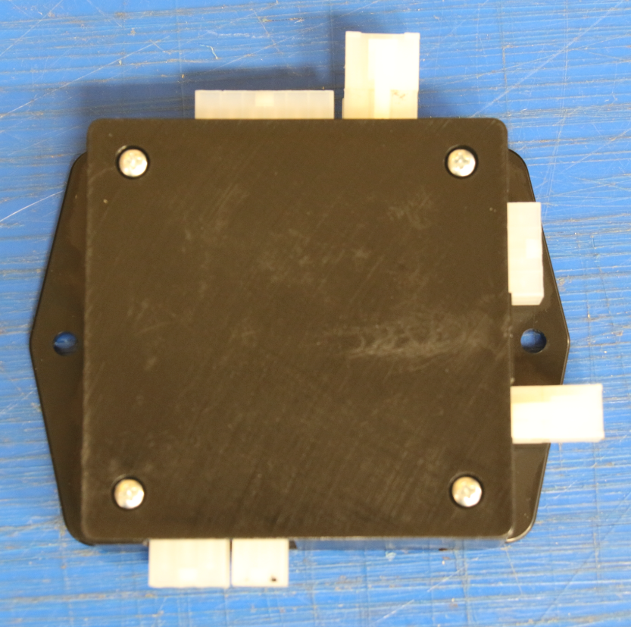
4
3
1
2
Figure 21: SCM layout
Once all connectors are attached to SCM it is recommended to calibrate the system before mounting SCM under dash (See section 22.0). If connectors are not plugged in correctly it will become apparent when calibrating the system.
After completing the calibration attach SCM under the dash using zip ties, Velcro, automotive double-sided tape (if there is a suitable flat surface) or self-tapping screws. Please read section 24.0 before mounting.

21.0 Selector Switch
The selector switch is only used for the calibration process, see Section 22. Once this has been completed you can remove the selector switch. The switch may be required if the system needs service, it is best practice to keep the selector switch keep in a safe place.

22.0 Calibration Process
1. Start the vehicle.
2. Make sure the On/Off Switch is in the On position, green light Illuminated
3. Ensure the OEM pedal and passenger side accelerator are at the idle position.
4. Press the selector switch push button one time. The LED on the selector switch push button will begin flashing rapidly.
5. Bring the I accelerator from the idle position to the 100% wide open throttle (WOT) position. Be sure to bring it to the 100% WOT position in one fluid motion. Hold the passenger side accelerator at 100% WOT for a minimum of one second.
6. Return the passenger-side accelerator to the idle position. The system will beep once.
7. Bring the factory pedal to the 100% WOT position. Be sure to bring it to the 100% WOT position in one fluid motion. Hold the factory pedal at 100% WOT for a minimum of one second.
8. Bring the factory pedal to the idle position. The system will beep once. The system is now calibrated and ready for testing.
9. Test the factory pedal by pressing on it slightly. Ensure that the engine is responsive to the factory pedal and that no warning lights appear on the dash.
10. Test the passenger side accelerator by pressing on it slightly. Ensure that the engine is responsive to the passenger side accelerator and that no warning lights appear on the dash.
NOTE: If there are any issues with the calibration process it will be apparent in step 6. If the engine idle RPM changes a recalibration must be performed (Section 23)

23.0 Recalibration
If the initial calibration is performed incorrectly, or the system is put into a different vehicle, a recalibration may be necessary. A special procedure must be followed to clear the current calibration.
To clear the calibration:
1. Turn off the ignition and verify the system is not powered. Vehicles with timed ignitions may require the door to be opened.
2. Hold the selector switch and the passenger side accelerator at 100% WOT.
3. Turn on the ignition while keeping the passenger side accelerator at 100% WOT and the selector switch depressed. The LED on the selector switch will blink rapidly.
4. Keep holding the passenger side accelerator at 100% WOT and the selector switch depressed until the selector switch has stopped blinking and remains illuminated.
5. Bring the passenger side accelerator to idle and release the push button. The LED on the selector switch will turn off.
6. Press the selector switch once. The LED will blink rapidly to notify the calibration has been cleared.
7. Turn off the system. This will leave the system with the calibration cleared.
8. Follow Steps 1-9 on page 24 to calibrate.
Note: Once the calibration is cleared, the system will always start up ready to be calibrated. The passenger-side accelerator will be unusable until a full calibration is performed.

24.0 House Keeping
Ensure all unused wires are cut and individually isolated with either heat shrink tubing or electrical tape and zip ties.
Make sure all connections made to the vehicle wiring are properly insulated from the vehicle chassis.
Check that all loose wires from the wire harness are fastened securely to the vehicle with zip ties or similarly permanent means. (See section 16.0)
Be sure not the fasten wires to any moving parts of the vehicle.
The SCM has two mounting flanges for easy installation. This box should be fastened to the vehicle chassis using either zip ties or screws. It is recommended to mount the box high under the dash to minimize the risk of water damage. Both flanges should be securely fastened to guarantee the SCM does not shift during operation.
Warning
Do not place any of the components in direct contact with any of the HVAC vents or modules. Failure to do so can result in failure of the system.

Appendix
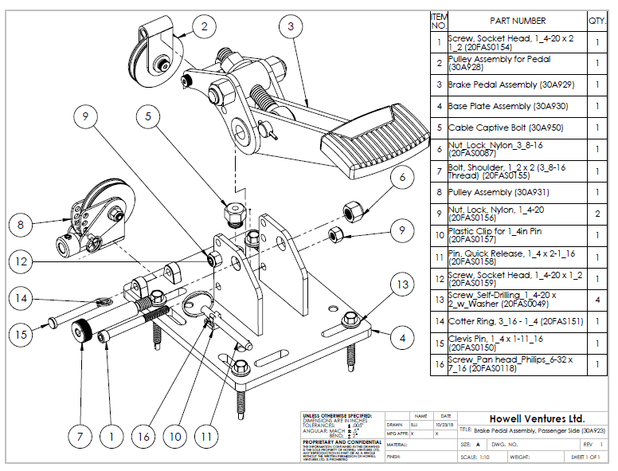
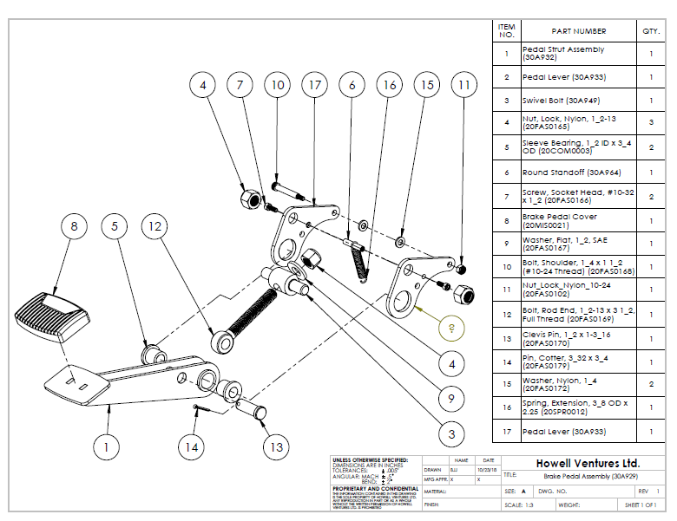

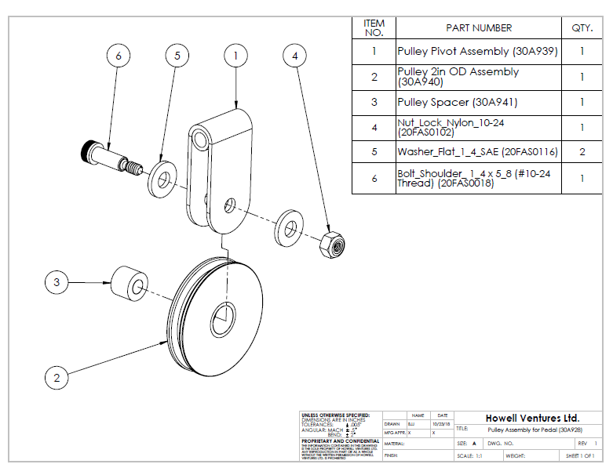

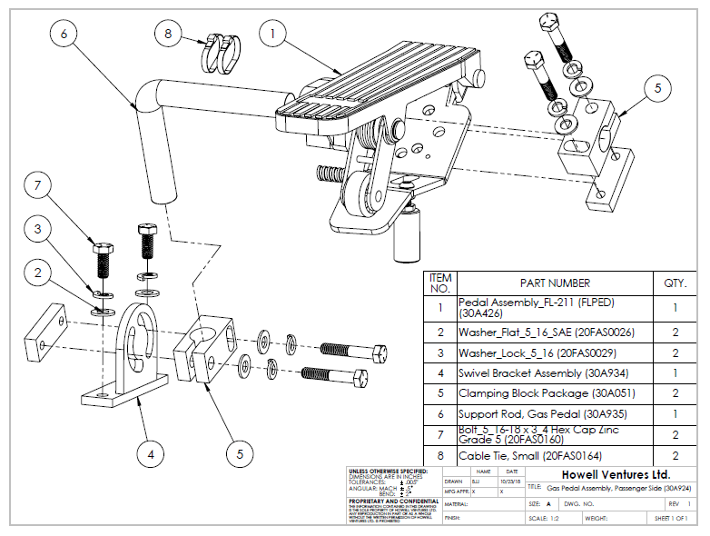

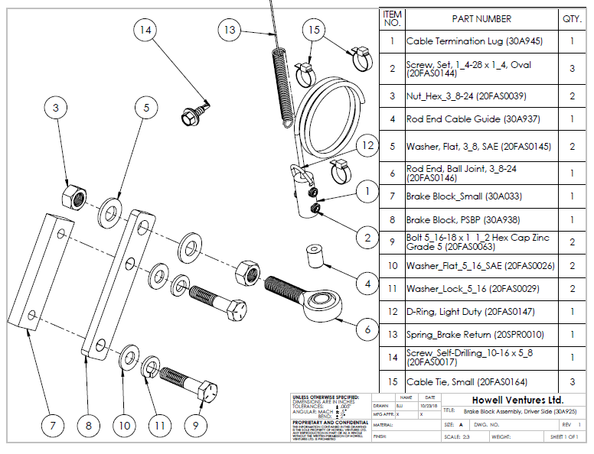

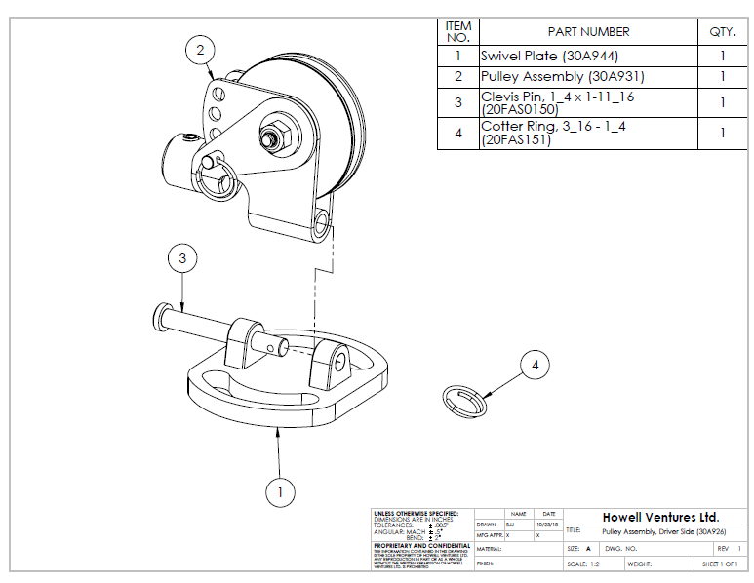
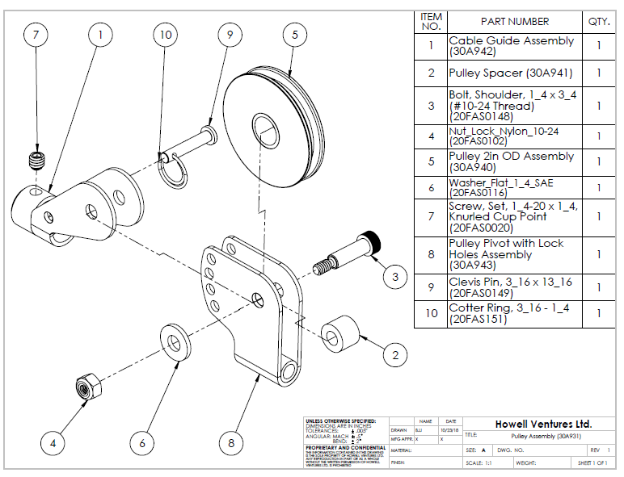
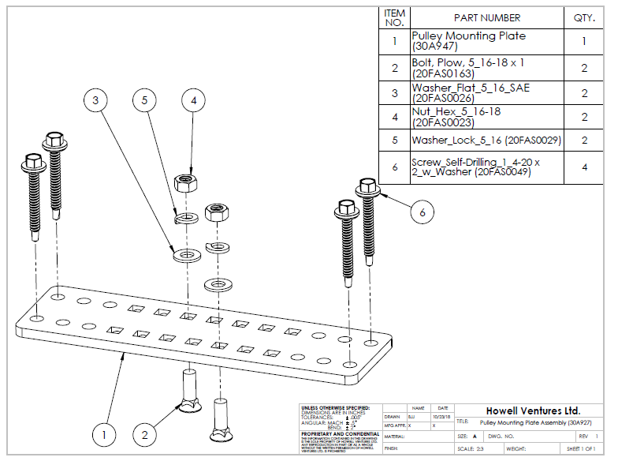

Service Record
DATE  MM/DD/YY | Technician/ Facility | Comments

NOTES:





